**DATABASE FOR BALTIMORE CITY COMMUNITY COLLEGE**

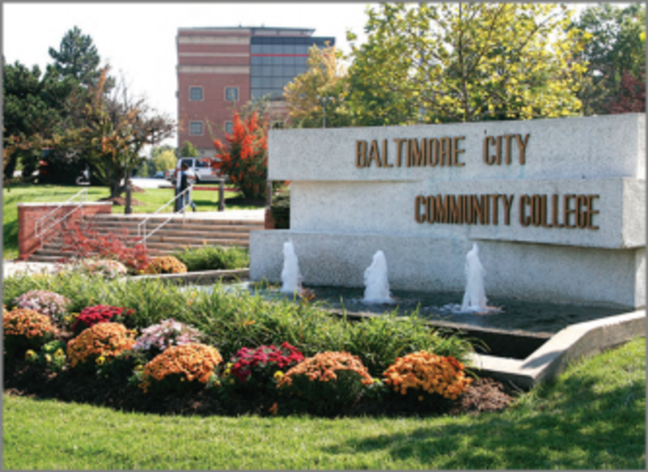

**DATABASE MANAGEMENT SYSTEMS PROJECT PREPARED BY:**

Dalton Brown | Matt Clark | Jacob Della | Christian Sauls

Towson University

Fall 2020

**Table of Contents**

**Introduction of Baltimore City Community College Database** **2**

# Introduction of Baltimore City Community College Database

Words go here

# BCCC Profile

More words

# BCCC Process Description

Words

# User Requirements

## Process Modeling Requirements

Words

## Data Modeling Requirements

Words

## Expected Database Queries

Words

# Entity Relationship Diagram

Use DIA

# Assumptions

Words

Insert Schema here

# Task List

|  |  |  |  |  |
| --- | --- | --- | --- | --- |
| Task Name | Duration | Start | Finish | Member Names |
| Analyzed School Requirements | 1 day | 9/24/20 | 9/24/20 | All |
| Drew ERD |  |  |  |  |
| Created Schema |  |  |  |  |
| Listed Possible Queries |  |  |  |  |
| Discussed Project Requirements |  |  |  |  |
| Finalized Project Report 1 |  |  |  |  |
| Submitted Project Report 1 |  |  |  |  |
| Created Database in MySQL |  |  |  |  |
| Created User Interface |  |  |  |  |
| Tested Database and Interface |  |  |  |  |
| Finalized Project |  |  |  |  |
| Submitted Project |  |  |  |  |
| Prepared Powerpoint |  |  |  |  |